Michael Knezevic

CST-105

4/15/2018

Hello Professor! This is my Milestone 1 that I have been working on which is a storyboard.

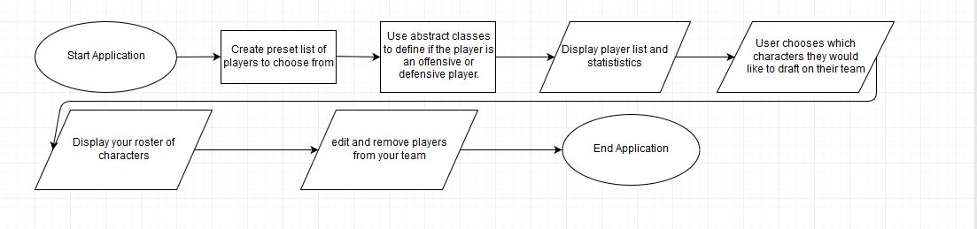

The user will begin by starting the application which would begin creating a list of players to choose from. Then we would use abstract classes to define whether the player is an offensive or defensive player which would then display both the players to choose from and their statistics. From here the user would view and choose which characters they would like to draft on to their team. Their roster would then appear on the screen showing which characters they have drafted and with this roster they will be able to add and remove players from their team.